Airbnb Business Analysis Using a Data Science Approach
Analytical Report - Track 1: Classical Machine Learning
Business question
How can an Automated Valuation Model (AVM) use listing, host, review and spatial features to predict Airbnb asking prices in New York City, and which geographic areas show the greatest pricing uncertainty?
Module: Machine Learning
Github repository: https://github.com/julesrif/ML-Airbnb-Business-Analysis

Team members:
Espinosa Rifel, Julio
Jukić, Džemal
Mehmood, Zee
Steyn, John-Jon
Tosto, Patrick

Submission date: 7 September 2026

1. Introduction
New Airbnb hosts need to set an asking price in a market where property type, location, host activity and customer engagement can all affect value. That is a difficult decision. Price too high and the listing may receive less interest. Price too low and the host loses revenue. An Automated Valuation Model (AVM) can give hosts a starting point using information Airbnb already holds when a property is listed.
This report examines how an Automated Valuation Model (AVM) can use listing, host, review and spatial features to predict Airbnb asking prices in New York City, and identifies neighbourhoods where those predictions are least certain. Using the 2019 New York City Airbnb dataset, enriched with neighbourhood, borough, public-transport and visitor-destination information (Gomonov, 2019; City of New York, 2020), it compares three regression models and uses K-means clustering to explore market segments.

2. Data and Method
Listings outside the New York City boundary were removed. Missing reviews-per-month values were replaced with zero. Listings with a price of zero or less, the top 1% of prices, and minimum stays above 365 nights were also removed. These steps reduced obvious errors and extreme cases that would distort model training. Price was transformed using log1p because the raw price distribution was heavily right-skewed.
The dataset was enriched with 2020 Neighbourhood Tabulation Areas, then linked to the nearest subway entrance and nearest of 12 selected visitor destinations. Room type and borough were one-hot encoded. This lets the models treat categories such as entire home, private room and shared room as distinct options rather than as an artificial ranking.
The regression analysis used an 80/20 training-test split. Decision Tree, Random Forest and Gradient Boosting regressors were tuned with three-fold GridSearchCV using root mean squared error in US dollars. Random Forest combines multiple decision trees, which can capture non-linear relationships between price, room type and location while reducing the instability of a single tree (Breiman, 2001).
K-means clustering used price, minimum stay, reviews, host listing count, availability, subway distance and visitor-destination distance. Features were standardised before clustering because K-means is distance based. Three clusters were selected using the elbow method and silhouette scores.

3. Results and Visualisations
Random Forest produced the strongest held-out performance of the three tested models. Its cross-validated RMSE was USD 74.46. On the held-out test set, it achieved a mean absolute error of USD 42.79, RMSE of USD 75.52, a dollar-scale R² of 0.484 and a log-price R² of 0.639. Gradient Boosting was close on log-price R² at 0.639, but Random Forest had lower dollar-scale test error. Decision Tree performed less strongly, with a log-price R² of 0.595.
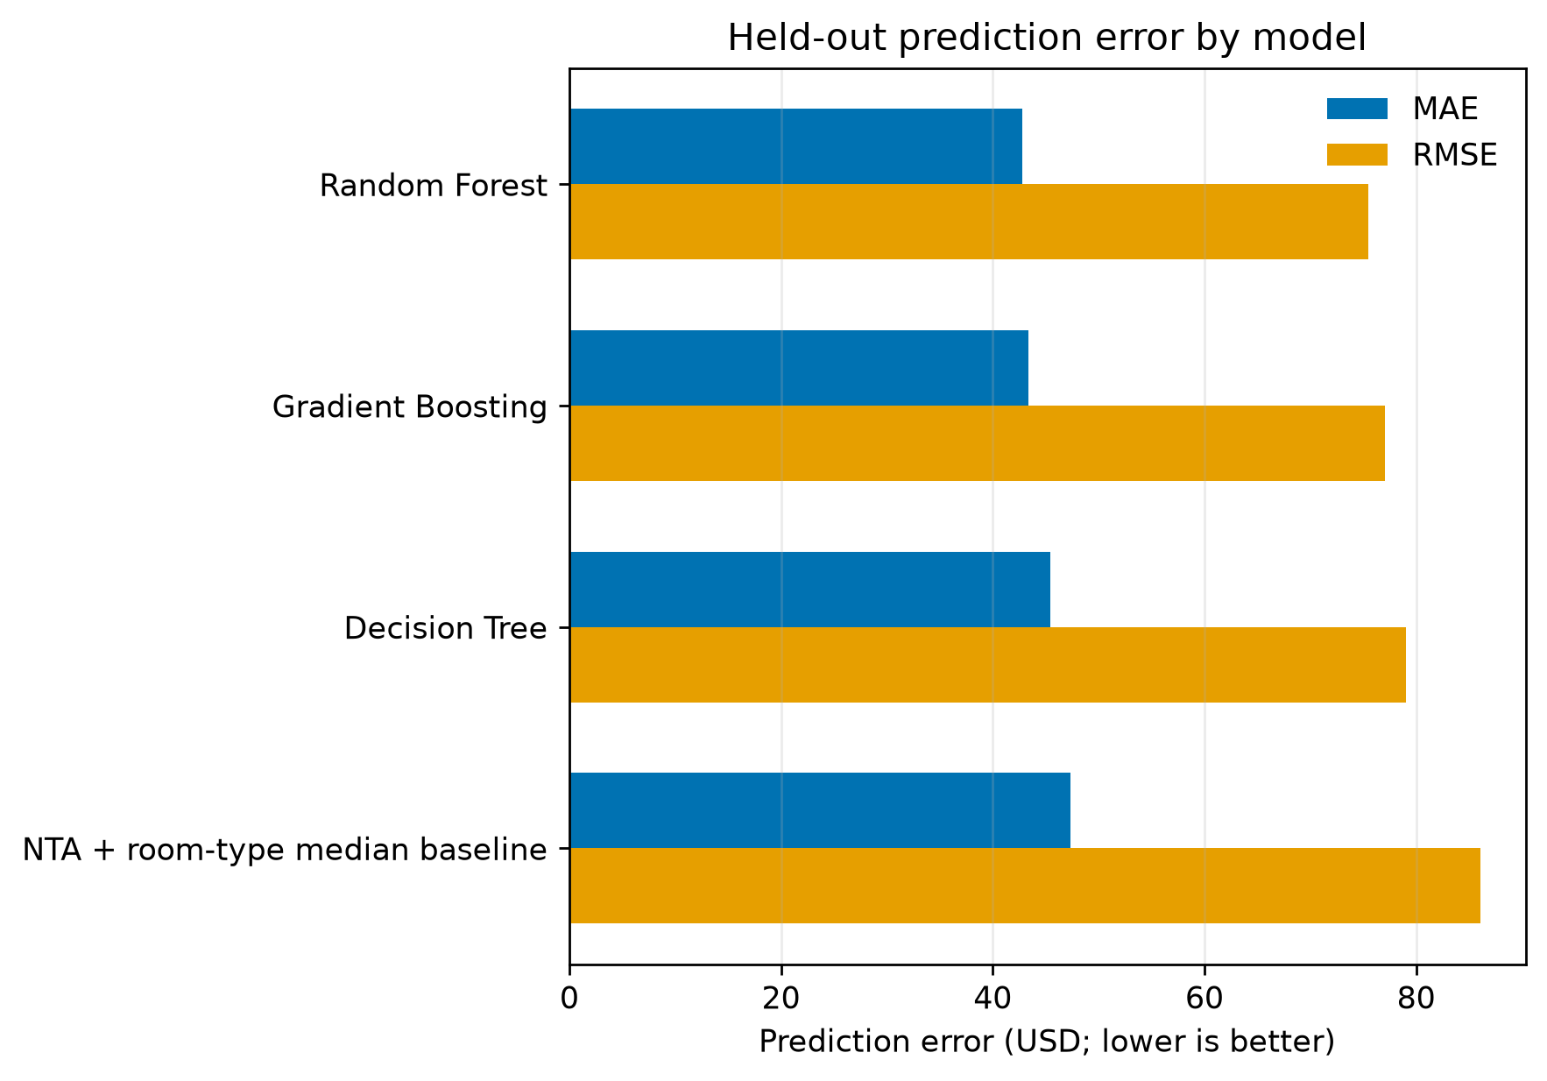
Figure 1. Model performance against the baseline. Random Forest produced the lowest held-out error among the tested models.
Feature importance showed that entire-home/apartment status was the strongest predictor, with an importance score of 0.432. Distance to a visitor destination was second at 0.165. Longitude, latitude, annual availability and distance to a subway also contributed. This fits the practical reality of Airbnb pricing: property type and location matter a lot. Review activity also helped the model, but it makes the model better suited to established listings than genuinely new ones.
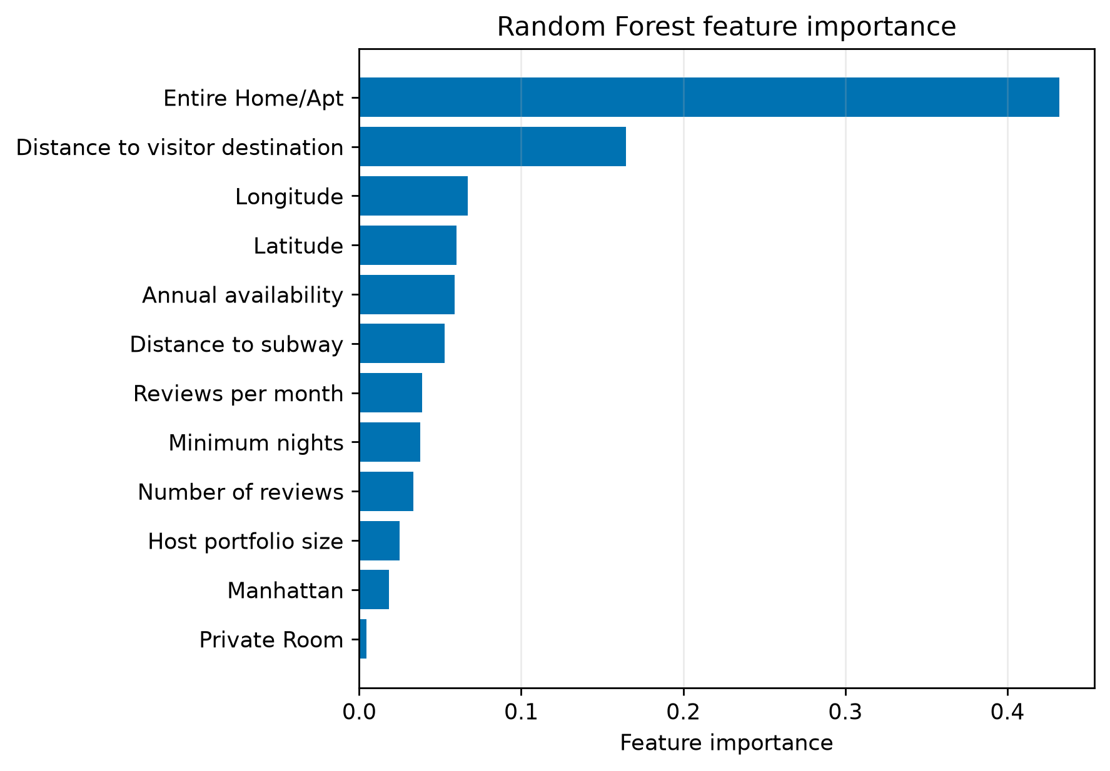
Figure 2. Random Forest feature importance. Entire-home/apartment status and distance to visitor destinations contributed most to the fitted model’s predictions.
The geographic error analysis found the highest mean out-of-fold absolute errors in Tribeca-Civic Center (USD 94.37), Midtown-Times Square (USD 85.18) and East Midtown-Turtle Bay (USD 72.52). These are areas where the model is less certain, not evidence that hosts are pricing incorrectly. The dataset does not capture property condition, interior quality, photographs, views or amenities in enough detail. Those unrecorded features are likely to matter more in premium central neighbourhoods.
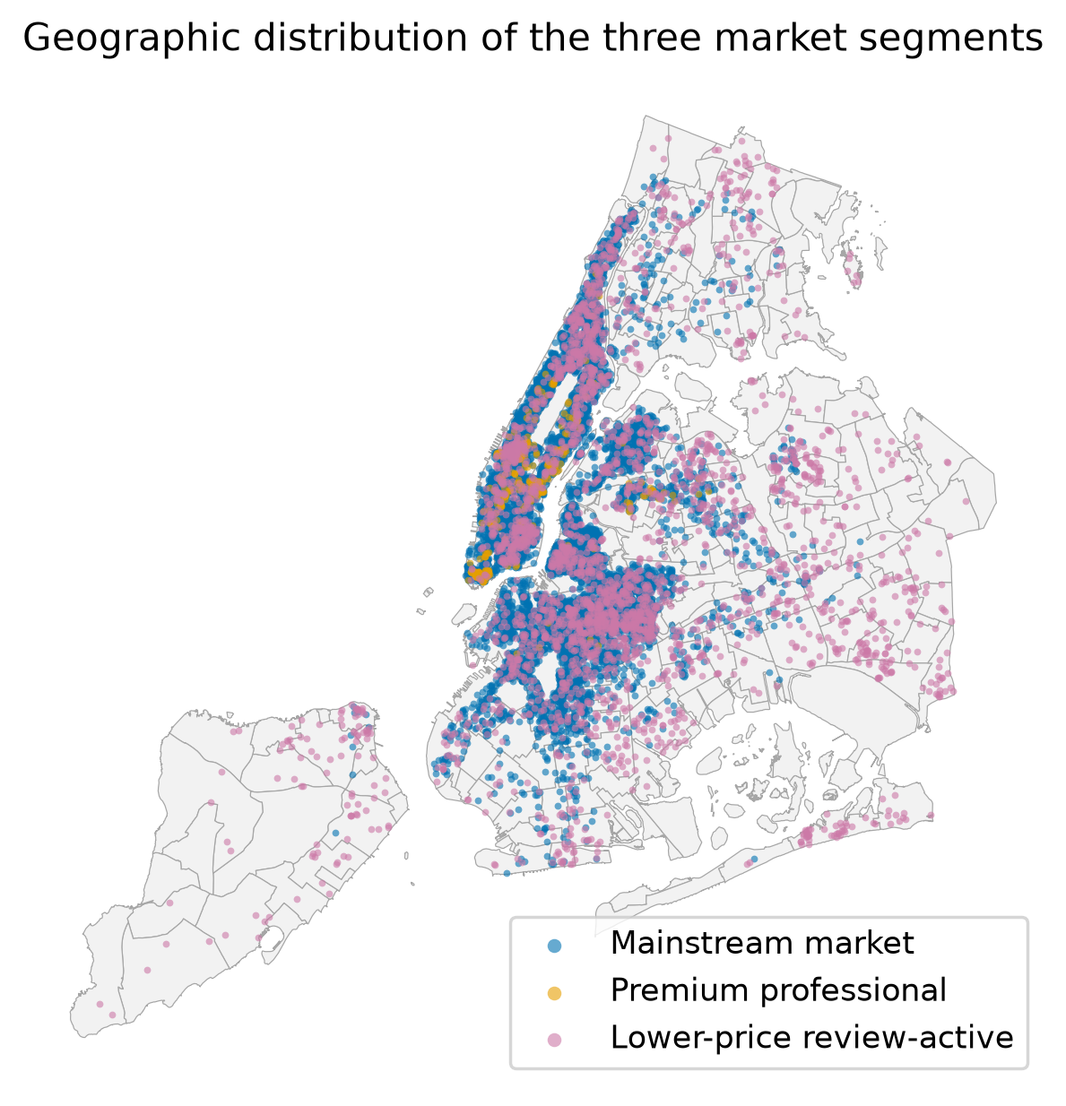
Figure 3. Geographic distribution of the three market segments.
K-means identified three exploratory listing groups. Cluster 0 was the mainstream market, containing 36,206 listings with an average price of USD 141.92. It included a near-even mix of entire homes/apartments and private rooms, and was concentrated mainly in Brooklyn and Manhattan. Cluster 1 was the premium professional segment. It contained 1,354 listings, averaged USD 225.47, was 88% entire homes/apartments and was 90% Manhattan. Cluster 2 was the lower-price, review-active segment. It contained 10,823 listings, averaged USD 112.02, was 52% private rooms and was more geographically dispersed across Brooklyn, Queens and other boroughs.
Listing density was highest in Manhattan and nearby parts of Brooklyn, with fewer listings across Queens, the Bronx and Staten Island.
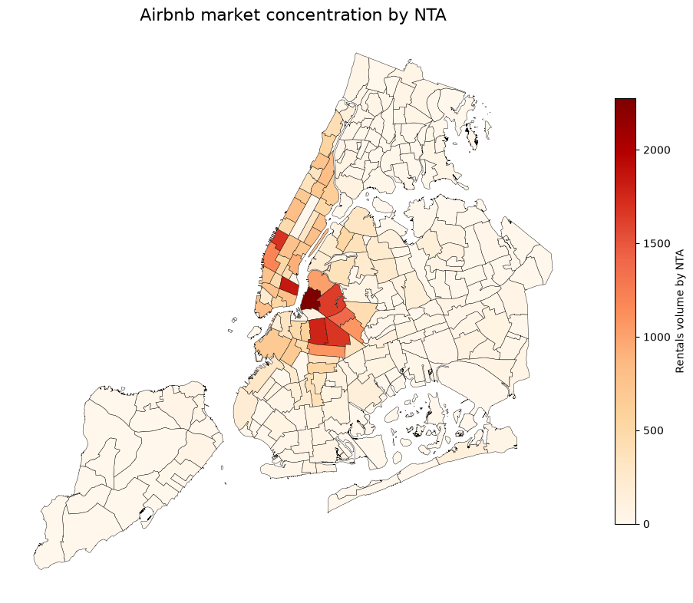
Figure 4. Listing density by neighbourhood. Darker areas contain more listings.
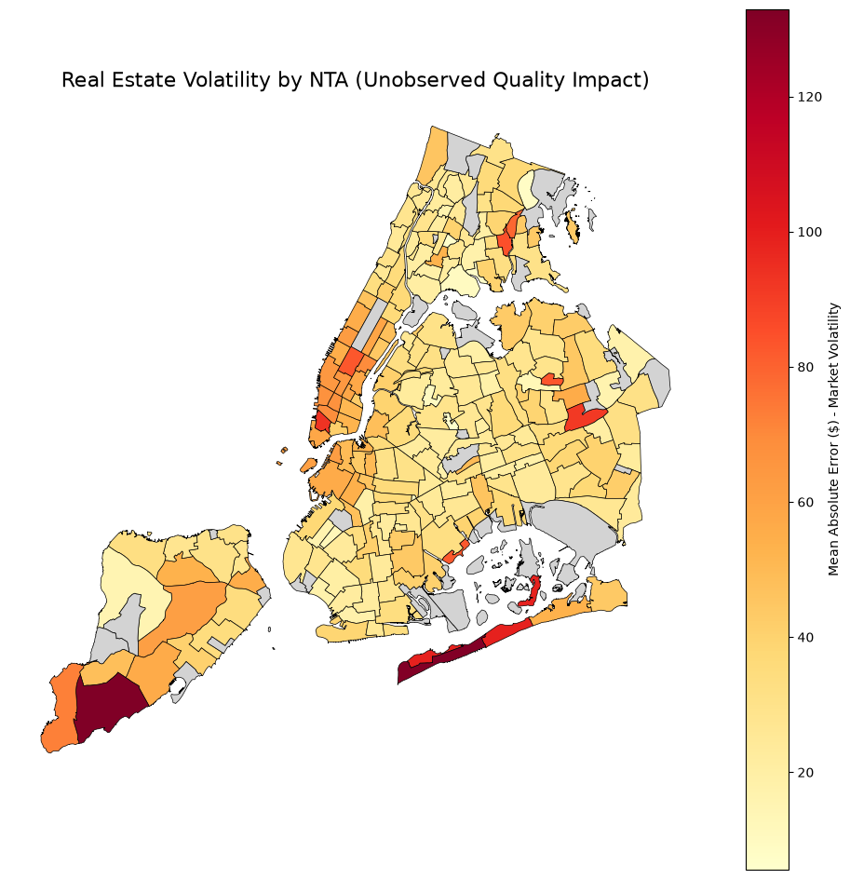
Figure 5. Model uncertainty by neighbourhood. Darker areas have higher out-of-fold prediction error.

4. Business Recommendations
Airbnb should use the AVM as a guided pricing tool, not as an automatic final price. A host should receive an initial price range, a central recommendation and a confidence indicator. This gives new hosts a useful starting point while making it clear that the platform has more certainty in some markets than others.
First, Airbnb should flag high-error neighbourhoods such as Tribeca-Civic Center, Midtown-Times Square and East Midtown-Turtle Bay. In these areas, the host dashboard should show a wider price range and prompt the host to add information about amenities, condition, photographs and unique features. Airbnb could also offer additional review or premium-host support before making a strong pricing recommendation.
Second, the onboarding process should make room type and location information easy to complete correctly. Entire-home/apartment status was the most important model feature, so inaccurate classification will weaken the recommendation from the start. Airbnb should validate this information early and explain why it affects pricing.
Finally, Airbnb should tailor support to the observed clusters. Cluster 1 hosts may benefit from premium-positioning and professional-host tools. Cluster 0 can receive mainstream price guidance and availability nudges. Cluster 2 may benefit from targeted visibility and review-building support. This is more useful than applying one citywide pricing approach to every host.

5. Conclusion
Random Forest gave the best results of the tested models. It explained 63.9% of the variation in log price and achieved a held-out MAE of USD 42.79. That makes it useful for giving hosts a first price recommendation, but not accurate enough to replace judgement completely.
The next step is to enrich the model with information on amenities, property condition, image quality and listing text. This could reduce error in premium neighbourhoods, where the available data does not fully capture the features that drive price.

References
Breiman, L. (2001) ‘Random forests’, Machine Learning, 45(1), pp. 5–32. Available at: https://doi.org/10.1023/A:1010933404324.
Chang, C. and Li, S. (2021) ‘Study of price determinants of sharing economy-based accommodation services: evidence from Airbnb.com’, Journal of Theoretical and Applied Electronic Commerce Research, 16(4), pp. 584–601. Available at: https://doi.org/10.3390/jtaer16040035.
City of New York (2020) 2020 Neighborhood Tabulation Areas (NTAs) – Mapped [Dataset]. Available at: https://data.cityofnewyork.us/City-Government/2020-Neighborhood-Tabulation-Areas-NTAs-Mapped/4hft-v355 (Accessed: 15 August 2026).
Friedman, J.H. (2001) ‘Greedy function approximation: A gradient boosting machine’, The Annals of Statistics, 29(5), pp. 1189–1232. Available at: https://doi.org/10.1214/aos/1013203451.
Géron, A. (2019) Hands-On Machine Learning with Scikit-Learn, Keras, and TensorFlow. 2nd edn. Sebastopol, CA: O’Reilly Media.
Gomonov, D. (2019) New York City Airbnb Open Data [Dataset]. Kaggle. Available at: https://www.kaggle.com/datasets/dgomonov/new-york-city-airbnb-open-data (Accessed: 16 August 2026).
Krstajic, D., Buturovic, L.J., Leahy, D.E. and Thomas, S. (2014) ‘Cross-validation pitfalls when selecting and assessing regression and classification models’, Journal of Cheminformatics, 6, 10. Available at: https://doi.org/10.1186/1758-2946-6-10.
Özçini, M.A., Yılmaz, T. and Kaya, T. (2023) ‘Clustering AirBnB listings in Istanbul using unsupervised machine learning techniques’, in Kahraman, C. et al. (eds.) Intelligent and Fuzzy Systems. Cham: Springer, pp. 192–199. Available at: https://doi.org/10.1007/978-3-031-39777-6_24.
Quinlan, J.R. (1986) ‘Induction of decision trees’, Machine Learning, 1(1), pp. 81–106. Available at: https://doi.org/10.1007/BF00116251.
Rosen, S. (1974) ‘Hedonic prices and implicit markets: Product differentiation in pure competition’, Journal of Political Economy, 82(1), pp. 34–55. Available at: https://doi.org/10.1086/260169.

